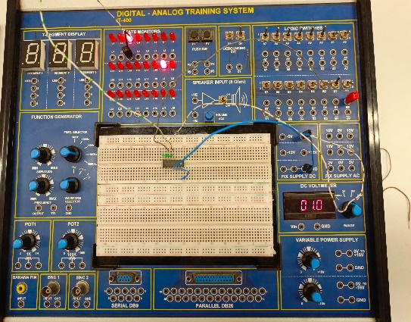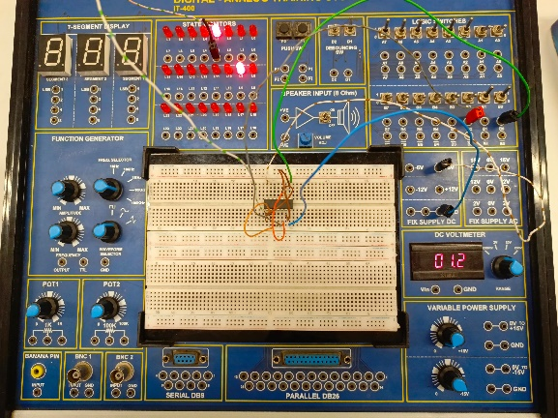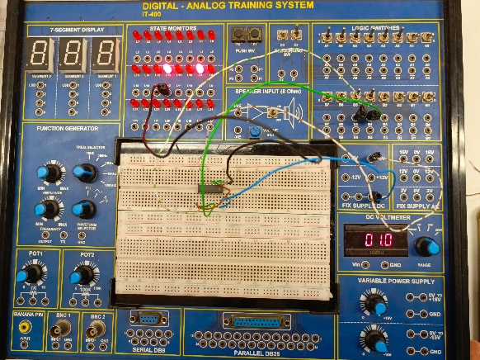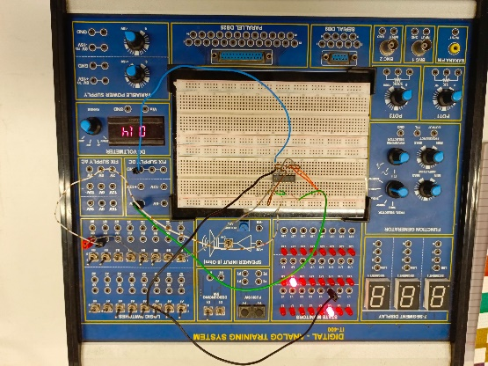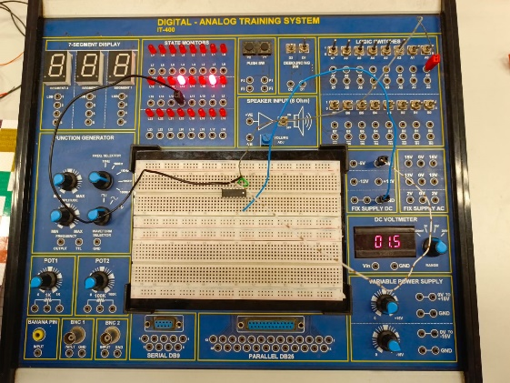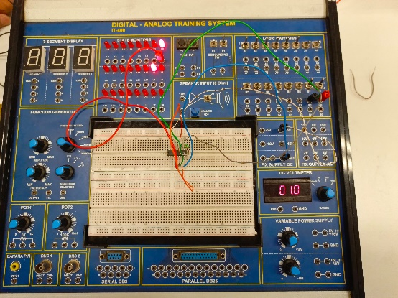**LAB 3 PHOTOGRAPHS**

Inverter using NOR Gate

AND Gate using NOR Gate

Inverter using NAND Gate

OR Gate using NOR Gate

OR Gate using NAND Gate

AND Gate using NAND Gate